Source code:

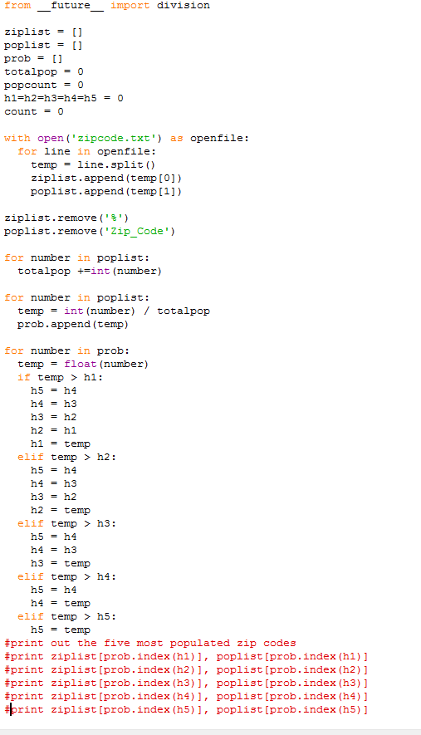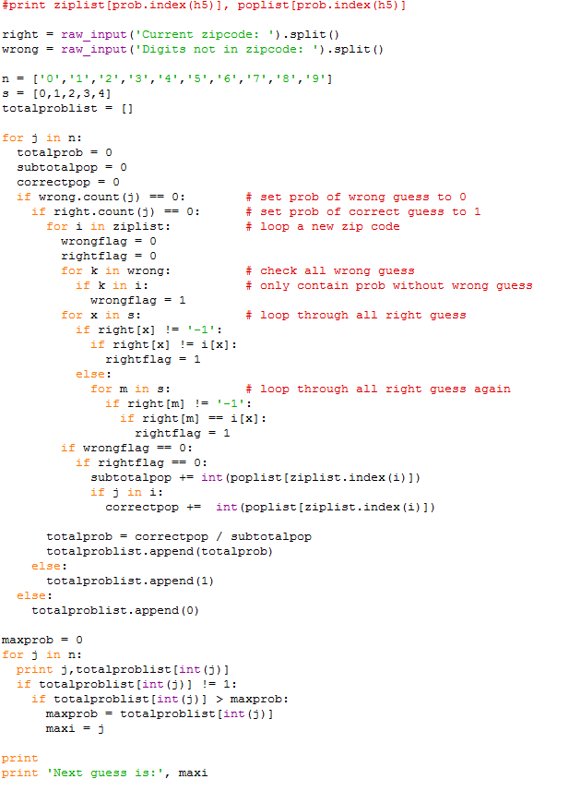

2.2 (a) The five most populated zip codes:

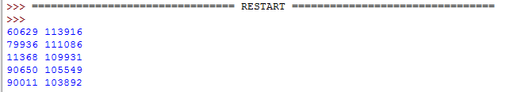

2.2 (b)

(i) First guess: -1 -1 -1 -1 -1

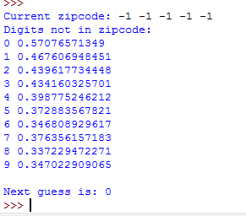

(ii) None correctly gussed: -1 -1 -1 -1 -1

Incorrectly guessed: 0, 4

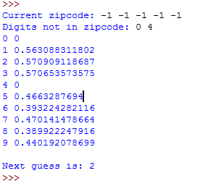

(iii) Correctly guessed: 8 -1 -1 7 -1

Incorrectly guessed: none

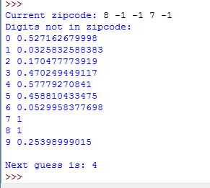

(iv) Correctly guessed: 9 2 -1 -1 9

Incorrectly guessed: 5, 6

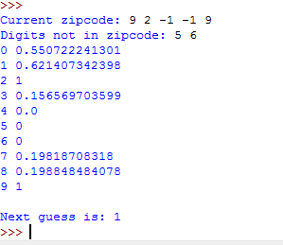

(v) Correctly guessed: -1 -1 7 0 3

Incorrectly guessed: 4, 5, 8, 9

